 STUDYLITCS LAB PRIVATED LIMITED
Email-director@studylitcslabs.com
Contact-8688825319
ABOUT US
Materials Testing is a range of highly precise and reliable techniques that determine and measure the characteristics of materials, such as mechanical properties, elemental composition, corrosion resistance and the effects of heat treatments.
Studylitcs Labs Pvt Ltd of premier activities is to test the various metals, composites, polymers, elastomers, and resins to determine their potential properties, performance, strength, durability, and resistance to corrosion and to ultimately help make certain that they are safe, compliant and fit for purpose in their end application.
Chemical analysis
Corrosion testing
Coatings testing
Failure analysis
Fracture mechanics
Fatigue testing
Material characterization
Mechanical testing
Services
We have mainly categorized our services into 2 types of equipments
- Processing equipments
  - Environmental Controlled High Temperature Furnace
Heat treatment in controlled atmosphere.
Specification:
Temperature: Room temperature to 1400 ⁰C
Heating rate : 0.5 0C/min to 10 0C/min
Environment : Air, Nitrogen, etc
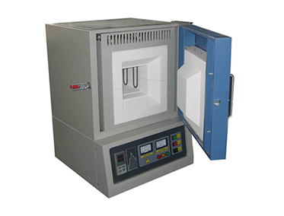
  - Specimen Cutting Machine
Metallic, polymer, etc
Specification:
RPM- 1500 max
Wheel size: 33 x 2 x 32 mm
Sample size (max): 30 mm x30 mm
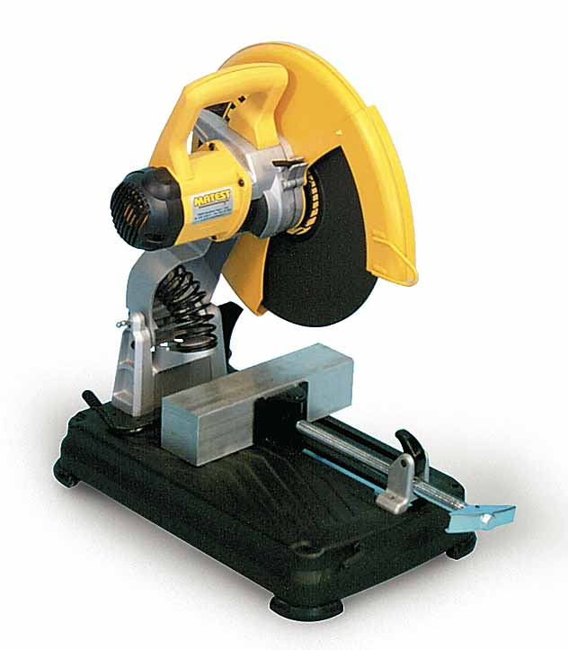
  - Single/Double Disc Polishing Machine
Polishing of samples to get smooth surface finish
Specification:
Diameter of disc: 200 mm
Rotation: 300-650 rpm
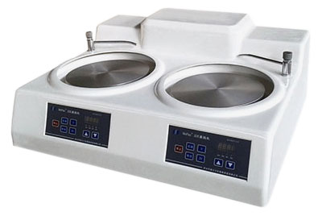

  - Universal Testing Machine
Studies of strain-strain behavior of materials
Specification:
Max force- 100 kN
Cross head speed- 5 mm/min to 100 mm/min
Travel length- 450 mm
Test types- Tension, Compression, and Flexural
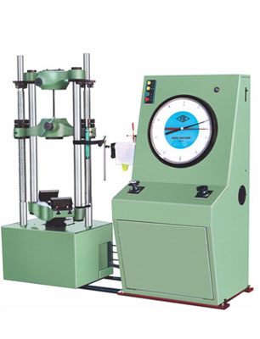

- Characterization Equipment
  - Shore A Durometer
Measurement of hardness for soft materials like rubber
Specification:
Preload: 0.45 Kgf
Major Load: 8.06 N
Indenter type- 35° truncated cone indenter
Type of load- Constant contact pressure
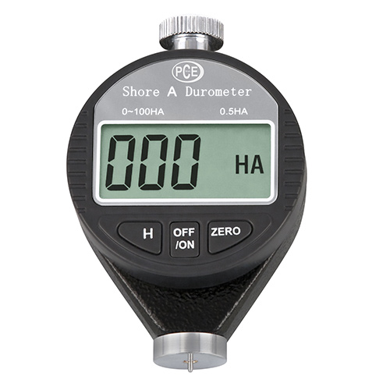
  - Shore D Durometer
Measurement of hardness for hard polymer
Specification:
Preload: 0.45 Kgf
Major Load: 44.48 N
Indenter type- 30° cone indenter
Type of load- Constant contact pressure
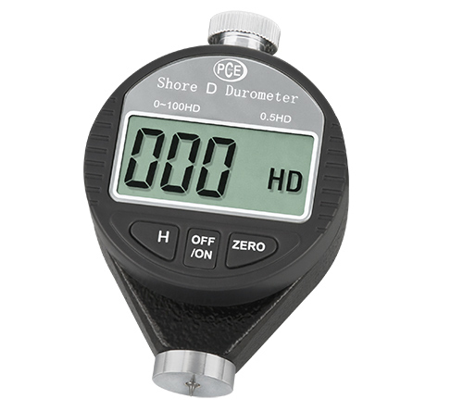

  - Metallography Station Trinolcular Optical Microscope with Camera
To study surface morphology
Specification:
Magnification- 25 X to 1200X
Focusing: Coarse to fine
Head: Monocular, binocular/trinocular
Illumination- Halogen, incident light
Eye piece: 5X, 10X, 15X and 20 X
Objective: 5X, 10X 20X and 40X
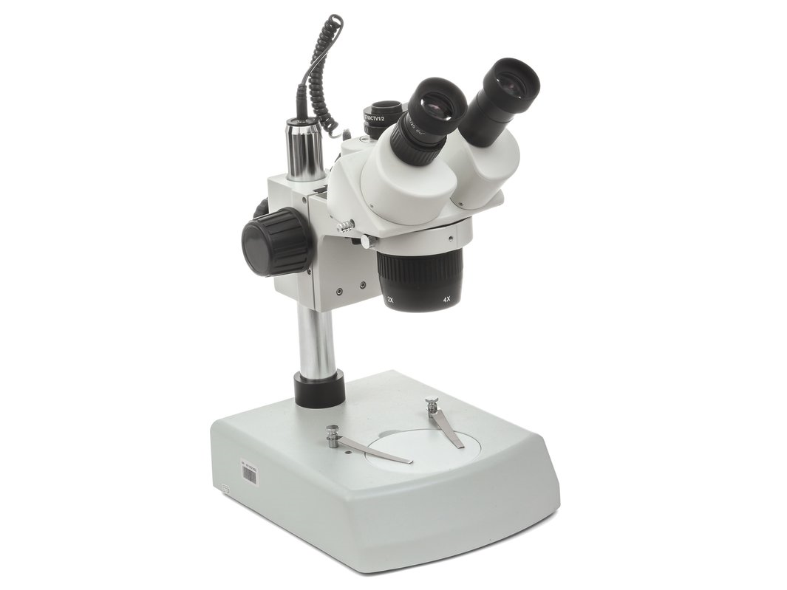
  - Surface Roughness Tester
Measurement of surface hardness
Specification:
Range: 350 m (-200 m to 150 m)
Detecting mode: Skid measurement
Measuring force: 4mN or 0.75 mN (Low force type)
Stylus tip: Diamond, 900/mR (600/2mR: low force type)
Travelling length : 6 mm
Evolution length (mm) : 1.25, 4.0
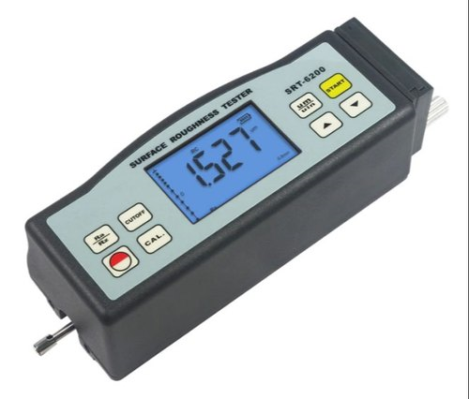
  - Superficial Rockwell Tester
Specification:
Range: 350 μm (-200 μm to 150 μm)
Detecting mode: Skid measurement
Measuring force: 4mN or 0.75 mN (Low force type)
Stylus tip: Diamond, 900/ 5μmR (600/2 μmR: low force type)
Travelling length : 6 mm
Evolution length (mm) : 1.25, 4.0
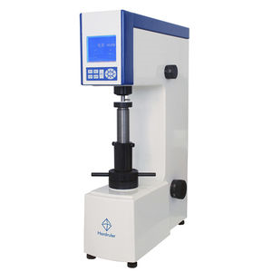

  - Brinell Hardness Tester
Brinell hardness test of Metals
Specification:
Preload: 250 Kgf
Major Load - 250-3000 Kgf in range of 250 Kgf
250, 500, 750, 1000, 1250, 1500 Kgf
Maximum test height- 410 mm
Depth of throat- 205 mm
Max depth of spindle below base – 180 mm
Steel ball diameter (Indentor)- 10 mm , 5 mm, 2.5 mm
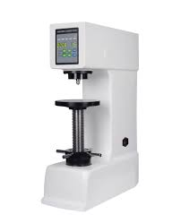
  - Vickers Hardness Tester
Vickers hardness tester of metals
Specification:
Load- 5 Kgf to 50 Kgf
30, 40, 50 Kgf (loads 5, 10, 15, 20 not working properly)
Indentor – diamond
Magnification- 25 X
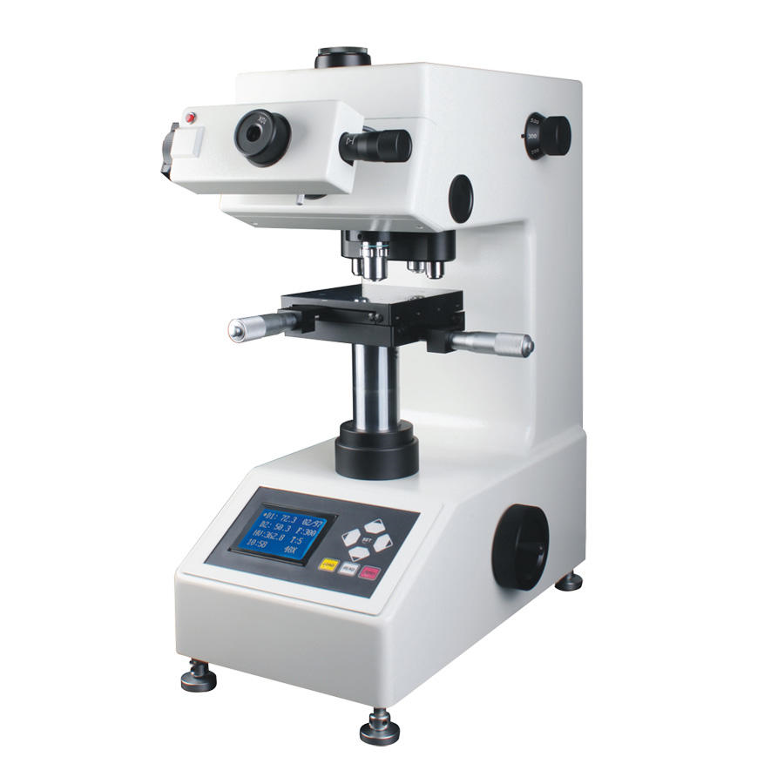
RESEARCH
RESEARCH plays an important role in discovering new treatments, and making sure that we use existing treatments in the best possible ways. Research can find answers to things that are unknown, filling gaps in knowledge.
Studylitcs Labs initiated research and development activities that focus on the innovation of new products or services in a company. Among the primary purposes of R&D activities is for a company to remain competitive as it produces products that advance and elevate its current product line. Since R&D typically operates on a longer-term horizon. However, in time, R&D projects may lead to patents, trademarks, or breakthrough discoveries with lasting benefits to the company. The following research activities initiated in the company are:
- Materials and Manufacturing Technology
- MATERIALS - We work on different types of materials like
- Composite: Currently, composites are used extensively in consumer products and building materials (in addition to the traditional industries) as a light weight, cost efficient alternative to metals. Parts as large as passenger aircraft fuselages are being constructed as a single unit from composite materials.
- Ceramics are inorganic, nonmetallic materials (such as carbides, oxides and nitrides) made by shaping at a high temperature. Ceramics are hard, brittle, heat- and corrosion-resistant, and most often have a crystalline structure
- Polymer materials are a kind of important materials that developed rapidly in biological applications. Synthetic polymer materials have many attractive properties, such as monodispersity, biocompatibility, controlled composition and chain length, and tunable chemical properties.
- Smart materials have properties that react to changes in their environment. This means that one of their properties can be changed by an external condition, such as temperature, light, pressure, electricity, voltage, pH, or chemical compounds.
Our main focus of latest updates in smart materials are on shape memory alloys, piezoelectric materials, electrostrictive materials, magnetostrictive materials, smart composites.
Along with this research on types of smart materials we also do our precise work on applications of smart materials like
- Smart materials used in batteries
- Smart materials used in SuperConductors
- Smart materials used in electronic circuits.
- Manufacturing technology – The key areas which we work on are
- Additive manufacturing allows the creation of lighter, more complex designs that are too difficult or too expensive to build using traditional dies, molds, milling and machining.
- Digital manufacturing is a fully integrated approach that manufacturers can leverage for planning, scheduling, quality management, cost control, material movement and shop floor operations. It means manufacturers are able to turn to digital technologies to make their shop floor more efficient.
- With big data analytics in manufacturing, manufacturers can discover new information and identify patterns that enable them to improve processes, increase supply chain efficiency and identify variables that affect production

- Energy
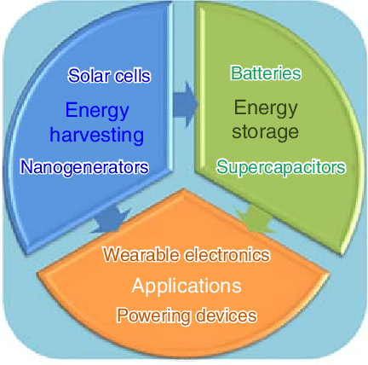
Our industry mainly works in energy harvesting and energy storage along with applications of these eneries in economically feasible possibilities.
There are many types of energy sources which are mainly classified into 2 types
- Renewable energy
- Non renewable energy
These energies which we get are harvested using energy harvesting devices like solar cells and panels, nanogenerators, wind mills etc. this energy which is harvested is sent to energy storage devices like batteries, capacitors, supercapacitors, flywheel etc., all the energy which is stored is used according to the required applications at appropriate time by seeing the economical feasibility of the energy applications. The energy is sent to processing units of motors, substations for transmission etc.,
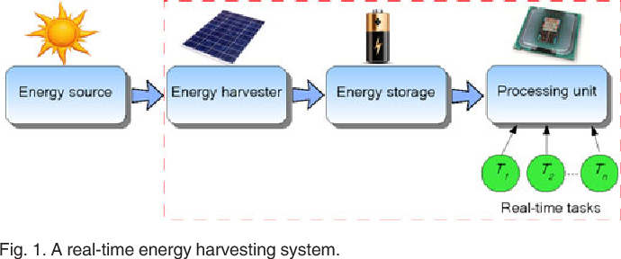
In our lab we set our goals to give our best results in energy harvesting and energy storage devices which mainly comprises of solar energy systems along with energy storage batteries.
Education
The primary purpose of educational research is to expand the existing body of knowledge by providing solutions to different problems in pedagogy while improving teaching and learning practices.
Studylitcs Labs mainly focus on educational research which develops the corridor between industry – institute. The gap reduces between industry and academic institutions through the organizing innovative program on latest concepts in technologies, internships and conducting certification programs on latest innovative courses, organizing workshops on innovative programs, teaches industry relavant courses. We focused on the following areas:
- Digital Manufacturing
- Additive Manufacturing
- Big Data Analytics in Manufacturing
- Smart Materials
- Renewable Energy Sources
GALLERY
